****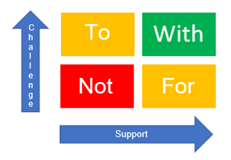

Punitive

Blaming

Stigmatizing

Authoritarian

Indifferent

Passive

Neglectful

Defensiveness

Little change

Growth

Profound change

Permissive

Rescuing

Excusing

Restorative

Cooperating

Collaborating

Accountable

No long term change

Mistrust

No change

The Social Discipline Window

‘*Human beings are happier, more cooperative and productive, and more likely to make positive changes in their behaviour when those in positions of authority do things WITH them, rather than TO them, or FOR them’ (International Institute for Restorative Practices)*