Restorative Practice &Trauma Informed Practice -naturally aligns
We need to ask:
Not ‘what is wrong with you?’ But rather:
‘What happened to you?’ And:
‘What needs didn’t get met?’

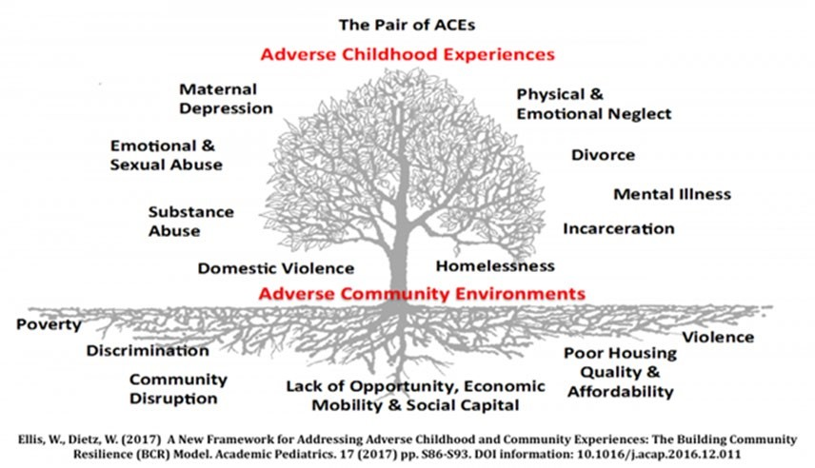

What do these concepts mean together – what do they look like ?
- Understanding, compassion, empathy, grace
- Trauma informed
- Being trusted /trusting
- Asking different questions/being curious
- Non judgmental/unconditional positive regard
- Collaborative/ individualised approach /shared goals
- Therapeutic alliance /connection /relationships
- Expectations, accountability and responsibility – high challenge /high support
- Not just with families/clients/ service users –it is with everyone we meet.
How does it sound?
- How can I help?
- I notice….
- What’s happening for you?
- Lets try and understand that a bit more.
- That sounds really difficult.
- Shall we look at it together ? • You are amazing –well done • Who else do you think can help?
- You’ve got this !

