Remote Access to the DCC Desktop or DCC Application
The Corporate Remote Access Gateway service is one which allows members of organisations working in partnership with Devon County Council and DCC employees to access many of its key ICT services.

It is important to note that not all applications are available through this service. Access to additional applications may be made through the ICT Self Service Portal.

Important Points to Remember

To use the Corporate Remote Access Gateway, you must meet the following prerequisites:
- You are a Devon County Council employee; or the organisation of your employ must have agreed to and signed Devon County Council’s Memorandum of Understanding (MOU); a copy of which is available from Devon County Council’s Information Governance section.

- You must hold a Devon County Council Corporate Desktop User Account.
- The service is protected through a secondary authentication method; typically, this is referred to as Two Factor Authentication or Multi Factor Authentication. Therefore, to use this service you must hold access to one of the following:
  - Mobile Phone with the ability to accept either text messages or incoming voice calls.
  - Smartphone with the Microsoft Authenticator App installed or the ability to accept either text messages or incoming voice calls.
  - Landline with the ability to accept incoming voice calls

- You must have access to a non-DCC desktop or laptop device with access to the Public Internet.

Devon County Council recommend that its Partners use Microsoft Windows 10 and must use Microsoft Internet Explorer to access this service.

The ICT ServiceDesk, through use of the ICT Self Service Portal will be able to advise as to whether your User account meets the service prerequisites.
.

How to access the DCC Full Desktop or DCC Application
- Open Internet Explorer and enter the address https://myapps.microsoft.com | 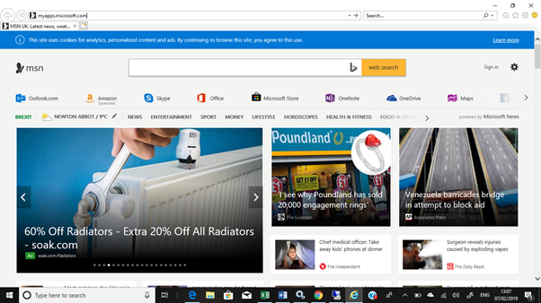
- When prompted enter your account name in the format firstname.lastname@devon.gov.uk | 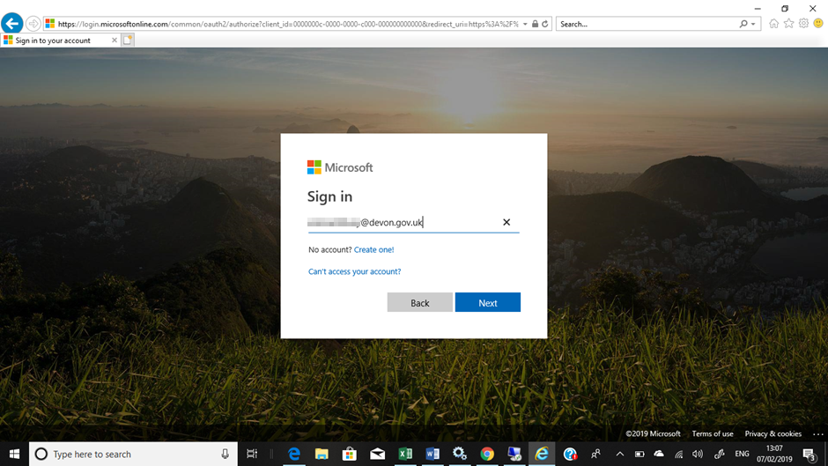
- The service will automatically redirect your browser to Devon County Council’s internal authentication service; the Organisational Account name will already be completed; simply enter the associated password. | 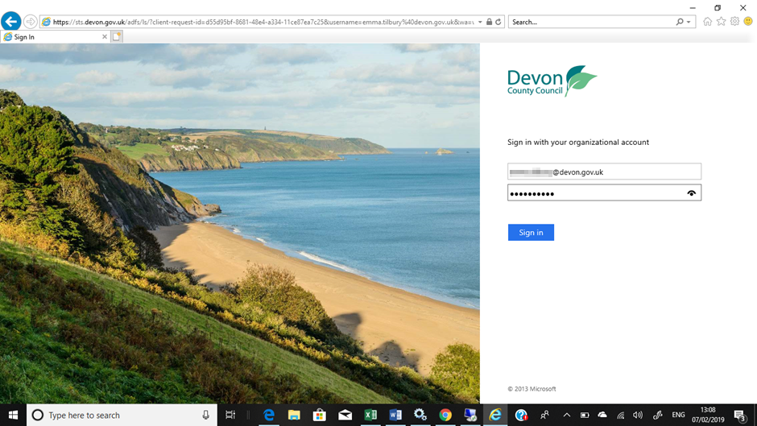
- If you have not previously used the service, or, if Multi Factor Authentication has not been configured against your account, you will be guided through setting this up. | 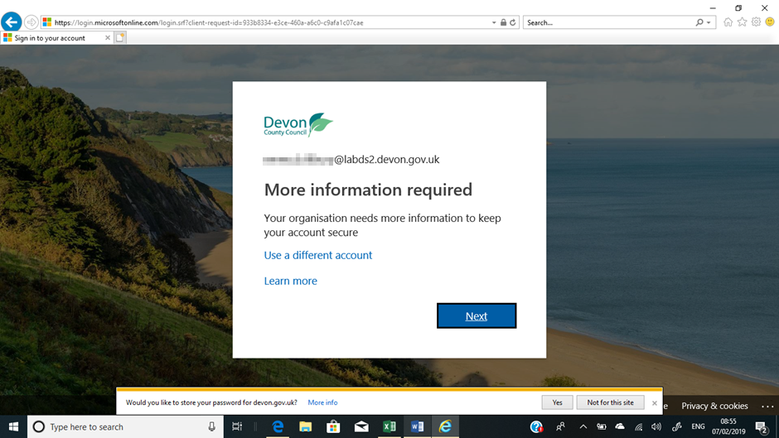
- Enter the additional information, click Next | 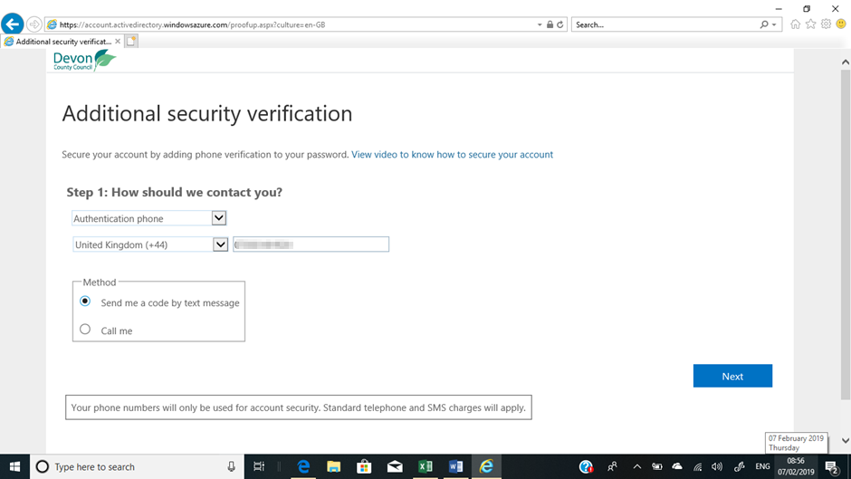
- If the verification code was sent by text, enter the verification code and click Verify.  If verification was via a voice call follow the instructions on the verification phone call. | 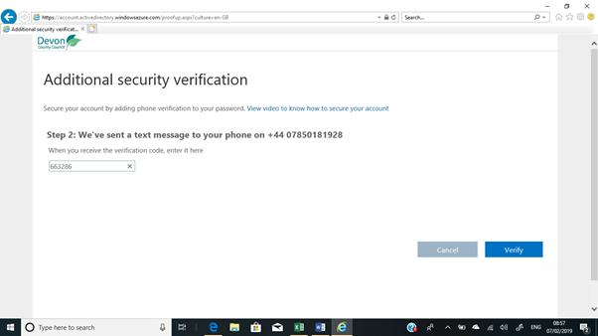
- At the Additional Security Verification page click Finished | 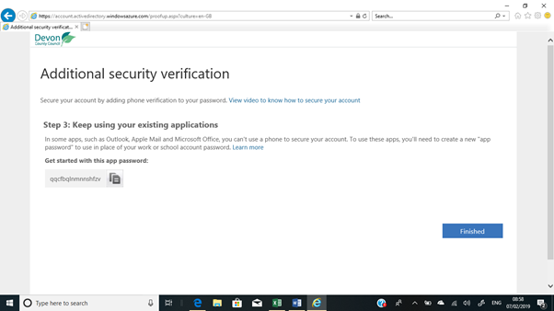
- When the Apps page loads click Remote Access Gateway | 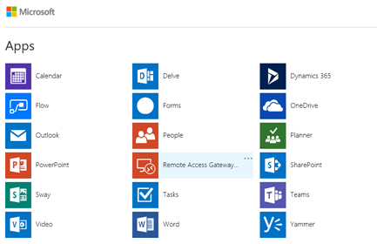
- At the Work Resources prompt enter your account name with the domain name in the format  ds2\firstname.lastname  Click Sign In | 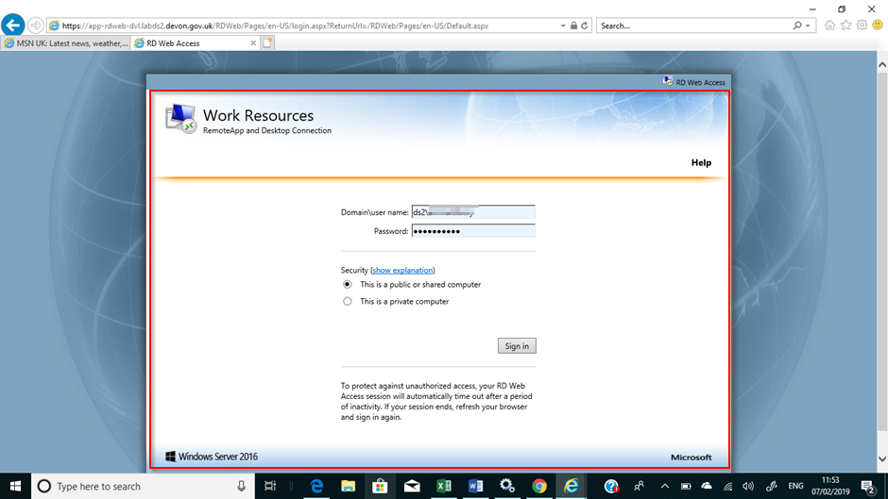
- If you see the following error message, please follow steps 11 - 13 | 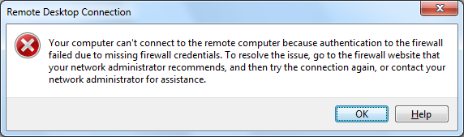
- If you are using the DCC Desktop on a device that isn’t corporately managed, you’ll need to add the web address to Trusted Sites. To do this click on the cog icon for Settings, then choose Internet Options | 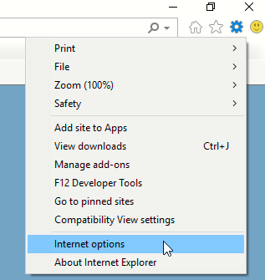
- Select the Security tab and Trusted Sites, click on Sites (please note if you are unable to click on Sites or do not see the Security tab, the device must be managed and your IT department will need to add the Trusted Site). | 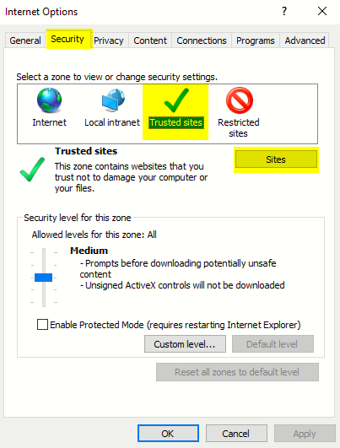
- Add the url https://app-rdweb.devon.gov.uk to the Trusted Sites, click Close  If you are unable to add the site to Trusted Sites. Please contact your IT department to do this by sharing the documentation found here | 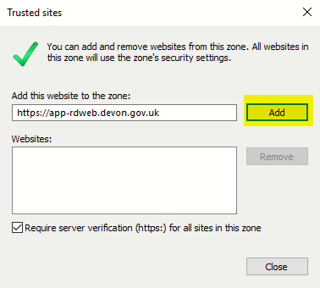
- Click on the DCC Full Desktop or the relevant Application | 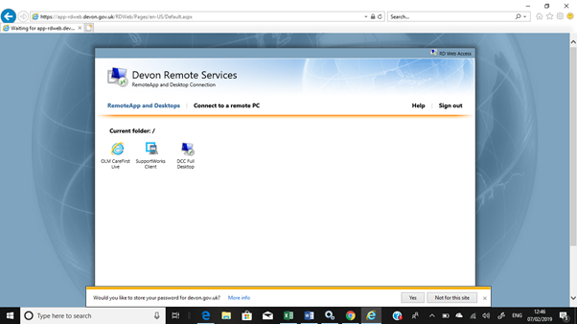
- Depending on the security policies of your organisation (something outside the control of Devon County Council) you may be presented with the following warning upon launching the <DCC Full Desktop> shortcut. This security warning is by design to inform the user that a RemoteDesktop session is about to be established with one or more local resource sharing options available (e.g. Printers), Some organisations will allow the users to hide this warning from appearing again by selecting “Don’t ask me again for remote connections from this publisher”; other users may have to accept / confirm this warning at the point of connection each time. | 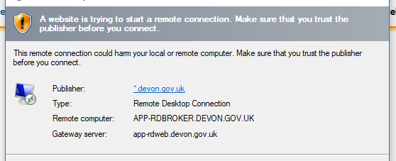
- To log off, click on Start button and then the DCC leaf logo | 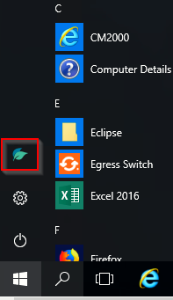
- Click Sign Out | 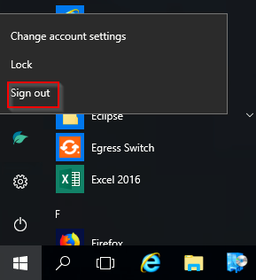
Things to Remember
This service is for Partners or Employers of Devon County Council who have access to a
- smartphone/ mobile phone / landline for multi-factor authentication
- a non-DCC device with access to the public internet
- If you are a Partner to Devon County Council, the organisation of your employ must have agreed to and signed Devon County Council’s Memorandum of Understanding (MOU); a copy of which is available from Devon County Council’s Information Governance section.

